
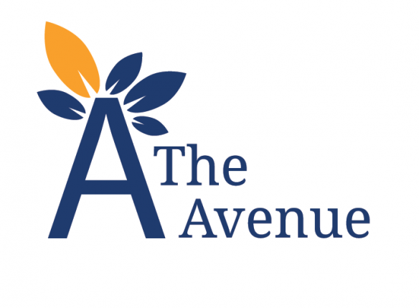

Literacy Policy and Guidance
2021-2022

Contents
Overview………………………………………………………………………………...……………..…….…3
KS1…………..…………………………………………………………………………………………………….. 4
KS2…………..………..…………………………………………..……………………………………………….5
KS3……….……………………………………….………………………………………………………………..6
Rationale (speaking and listening, reading and writing)…….………………………..7-12
Appendices…………………………………………………………………………………………………….13
Appendix 1: Curriculum Intent /Key Stage End Points (KS1/2 and 3)………………………..….13-15
Appendix 2: Little Wandle Letters and Sounds Revised: Programme progression…………16-18
Appendix 3: Supporting development of writing ............................................................19-21
Appendix 4: Building blocks of development ........................................................................22
Appendix 5: Teaching strokes and letters (ABC Boom!)………………………………………………..23-24
Appendix 6: Little Wandle Letters and Sounds Revised grapheme information sheets...26-27

Literacy

 | Communication | Reading | Writing
 | Receptive language -Listening | Pre-reading | Engagement and enjoyment
 | - Consistent, simple language in routines  - Key words  - Blank’s Levels of Questioning  - Targeted vocabulary and concept development  - Use of symbols and Makaton signing | - Daily speaking and listening activities  - Context based print  - Print-rich classroom environment | - Using meaningful and motivating tasks or themes for colouring, mark making and writing (eg linked to curriculum theme books, drawing/ writing about personal experiences and events, writing shopping lists or making cards for family/ friends, etc)
 | Expressive language - Speaking | Early reading and phonics | Grammar and punctuation
 | - ‘Means, reasons and opportunities to communicate’  - Developing vocabulary, syntax and grammar  - Alternative and augmentative communication  - Speech intelligibility  - Fluency | - Little Wandle Letters and Sounds Revised phonics programme  - Little Wandle Letters and Sounds Revised decodable books (home/school) reading)  - Reading Eggs (online reading) programme (home/school reading) | - Contextualised approach (drawing on authentic examples from quality reading, exploring the effect and impact of the use of grammar and punctuation)
 |  | Reading for enjoyment | Spelling
 |  | - The Power of Reading approach (high quality texts and creative teaching approaches, including ‘irresistible’ storytelling)  - Multi sensory books  - Weekly school library sessions (home/school reading)  - Local library visits (KS2+) | - Repertoire of interactive games, whiteboard work and mnemonics  - Spelling books
 |  | Reading for meaning | Handwriting
 |  | - Before-During-After approach to reading  - Little Wandle Letters and Sounds Revised decodable books (home/school reading) | - Activities to promote fine motor skills, functional pencil grasp and efficiency and confidence in producing written work incorporated into class lessons  - Multi-sensory ABC Boom! handwriting programme to teach letter strokes and letter formation  - Keyboarding skills

KS1
Total Communication Approach
SaLT Essential and Enhanced Provisions (including assessment on entry, if applicable and intervention) and Family Provision
Communication, Language and Literacy | Receptive- Listening | Expressive - Speaking
Communication, Language and Literacy | - Use of consistent, simple language in routines  - Develop pupils’ abilities to follow instructions (information carrying words)  - Develop pupils’ verbal reasoning skills according to Blank’s Levels of Questioning  - Expand pupils’ vocabulary and conceptual understanding  - Introduce symbols with written words and/or Makaton signing to support pupils’ understanding in all learning and communication opportunities | - Applying the ‘means, reasons and opportunities’ model to supporting pupils’ communication development  - Modelling and teaching of functions of language, requesting, labelling, commenting, narrative etc  - Supporting the pupils’ development of syntax and grammar, eg through the use of Colourful Semantics or Shape Coding  - Providing and refining Augmentative Communication (AAC) systems where needed (including Makaton signing, communication books/boards, Pragmatic Organisation Dynamic Display [PODD] books, the Picture Exchange Communication System (PECS), Voice Output Communication Aids (VOCA)  - Support pupils’ speech intelligibility (including the Nuffield Dyspraxia Programme) if deemed appropriate following assessment and/ or intervention
Pre-reading | - Daily speaking and listening activities, print-rich classroom environment and context based print
Early Reading and Phonics | - Little Wandle Letters and Sounds Revised systematic synthetic phonics programme at appropriate phase,-s  - Little Wandle Letters and Sounds Revised decodable books (home/school reading)  - Reading Eggs online reading programme (home/school learning)
Reading for Enjoyment | - High quality texts (see KS1 book list) and creative teaching approaches  - Multi-sensory books  - Pupils actively involved (ie doing different actions linked to content of story) during group story time  - Symbol books created using InPrint2 software and photo books  - Weekly school library sessions (home/school reading)
Writing Engagement and Enjoyment | - Extending activities that are meaningful and motivating for the individual pupil to incorporate strokes, letters, or words, ie making strokes, letters or words in sand, foam, or other tactile trays, out of playdough or putty, using magnetic letters, iPad apps, labelling their pictures, producing written work on the computer.  - Using meaningful and motivating themes for writing, eg linked to curriculum theme or preferred books, writing about personal experiences and events, writing shopping lists or cards to friends/family.  - Opportunities for free writing  - Colouring, drawing, writing activities to be done in different positions, ie on stomach on the floor, standing at an easel or with large sheets of paper on the wall
Handwriting | - Access to advice and support from OT to promote gross and fine motor skills required for increased efficiency in writing, to be incorporated within lessons/activities  - Use of multi-sensory handwriting programme ABC Boom! To continue to introduce letter strokes and consolidate understanding and ability to produce letter strokes, introduce formation of letters/ numbers or to correct inaccurate letter formation (depending on individual stage of writing)  - Provision of OT equipment (ie Movin’sit cushion, inclined plane, pencil grip) to support individual’s efficiency within writing (where required)  - Collaboration between OT and class team to review needs and adapt interventions
KS2
Total Communication Approach
SaLT Essential and Enhanced Provisions (including assessment on entry, if applicable, and intervention) and Family Provision
Communication, Language and Literacy | Receptive- Listening | Expressive - Speaking
Communication, Language and Literacy | - Use of consistent, simple language in routines  - Continue to develop pupils’ abilities to follow instructions (information carrying words)  - Continue to develop pupils’ verbal reasoning skills according to Blank’s Levels of Questioning  - Continue to expand pupils’ vocabulary and conceptual understanding  - Introduce symbols with written words and/or Makaton signing to support pupils’ understanding in all learning and communication opportunities | - Applying the ‘means, reasons and opportunities’ model to supporting pupils’ communication development  - Modelling and teaching of functions of language: requesting, labelling, commenting, narrative etc  - Supporting the pupils’ development of syntax and grammar, eg through the use of Colourful Semantics or Shape Coding  - Providing and refining Augmentative Communication (AAC) systems where needed (including Makaton signing, communication books/boards, Pragmatic Organisation Dynamic Display [PODD] books, the Picture Exchange Communication System (PECS), Voice Output Communication Aids (VOCA)  - Support pupils’ speech intelligibility (including the Nuffield Dyspraxia Programme) if deemed appropriate following assessment and/ or intervention
Pre-reading | - Daily speaking and listening activities, print-rich classroom environment and context based print
Early Reading and Phonics | - Little Wandle Letters and Sounds Revised systematic synthetic phonics programme at appropriate phase,-s  - Little Wandle Letters and Sounds Revised decodable books (home/school reading)  - Reading Eggs online reading programme (home/school learning)
Reading for Enjoyment | - High quality texts (see KS2 book list) and creative teaching approaches  - Multi-sensory books  - Pupils actively involved (ie doing different actions linked to content of story) during group story time  - Symbol books created using InPrint2 software and photo books  - Weekly school/ local library sessions (home/school reading)
Writing Engagement and Enjoyment | - Continued opportunities to produce strokes, letters, or words within activities that are meaningful and motivating for the individual pupil to incorporate strokes, letters or words, ie making strokes, letters or words in sand, foam, or other tactile trays, out of playdough or putty, using magnetic letters, iPad apps, labelling their pictures, producing written work on the computer.  - Using meaningful and motivating themes for writing, eg linked to curriculum theme or preferred books, writing about personal experiences and events, writing shopping lists or cards to friends/family.  - Opportunities to engage in creative writing, ie poems, short stories.  - Colouring, drawing, writing activities to be done in different positions, ie on stomach on the floor, standing at an easel or with large sheets of paper on the wall.
Handwriting | - Access to advice and support from OT to promote gross and fine motor skills required for increased efficiency in writing, to be incorporated within lessons/activities  - Use of multi-sensory handwriting programme ABC Boom! To continue to introduce letter strokes and consolidate understanding and ability to produce letter strokes, introduce formation of letters/ numbers or to correct inaccurate letter formation (depending on individual stage of writing)  - Provision of OT equipment (ie Movin’sit cushion, inclined plane, pencil grip) to support individual’s efficiency within writing (where required)  - To introduce joined up writing style as appropriate  - Collaboration between OT and class team to review needs and adapt interventions
KS3
Total Communication Approach
SaLT Essential and Enhanced Provisions (including assessment on entry, if applicable, and intervention) and Family Provision
Communication, Language and Literacy
Communication, Language and Literacy | - Use of consistent, simple language in routines  - Continue to develop pupils’ abilities to follow instructions (information carrying words)  - Continue to develop pupils’ verbal reasoning skills according to Blank’s Levels of Questioning  - Continue to expand pupils’ vocabulary and conceptual understanding  - Introduce symbols with written words and/or Makaton signing to support pupils’ understanding in all learning and communication opportunities | - Applying the ‘means, reasons and opportunities’ model to supporting pupils’ communication development  - Modelling and teaching of functions of language: requesting, labelling, commenting, narrative etc  - Supporting the pupils’ development of syntax and grammar, eg through the use of Colourful Semantics or Shape Coding  - Providing and refining Augmentative Communication (AAC) systems where needed (including Makaton signing, communication books/boards, Pragmatic Organisation Dynamic Display [PODD] books, the Picture Exchange Communication System (PECS), Voice Output Communication Aids (VOCA)  - Support pupils’ speech intelligibility (including the Nuffield Dyspraxia Programme) if deemed appropriate following assessment and/ or intervention
Pre-reading | - Daily speaking and Listening activities, print-rich classroom environment and context based print
Early Reading and Phonics | - Little Wandle Letters and Sounds systematic synthetic phonics at appropriate phase,-s  - Little Wandle Letters and Sounds Revised decodable books (home/school reading)  - Reading Eggs online reading programme (home/school learning)
Reading for Enjoyment | - High quality texts (see KS3 book list) and creative teaching approaches  - Multi-sensory books  - Pupils actively involved (ie doing different actions linked to content of story) during group story time  - Symbol books created using InPrint2 software and photo books  - Weekly school/ local library sessions (home/school reading)
Writing Engagement and Enjoyment | - Continued opportunities to produce strokes, letters, or words within activities that are meaningful and motivating for the individual pupil to incorporate strokes, letters or words, ie making strokes, letters or words in sand, foam, or other tactile trays, out of playdough or putty, using magnetic letters, iPad apps, labelling their pictures, producing written work on the computer.  - Using meaningful and motivating themes for writing, eg linked to curriculum theme or preferred books, writing about personal experiences and events, writing shopping lists or cards to friends/family.  - Opportunities to engage in creative writing, ie poems, short stories to present/share.  - Colouring, drawing, writing activities to be done in different positions, ie on stomach on the floor, standing at an easel or with large sheets of paper on the wall.
Handwriting | - Access to advice and support from OT to promote gross and fine motor skills required for increased efficiency in writing, to be incorporated within lessons/activities  - Use of multi-sensory handwriting programme ABC Boom! To continue to introduce letter strokes and consolidate understanding and ability to produce letter strokes, introduce formation of letters/ numbers or to correct inaccurate letter formation (depending on individual stage of writing)  - Provision of OT equipment (ie Movin’sit cushion, inclined plane, pencil grip) to support individual’s efficiency within writing (where required)  - To introduce joined up writing style or IT programme as appropriate  - Collaboration between OT and class team to review needs and adapt interventions
Rationale
Literacy underpins the school curriculum by developing pupils’ abilities to speak, listen, read and write for a wide range of purposes, using language to learn and communicate, think and explore. Helping pupils to express themselves clearly orally and in writing enhances and enriches teaching and learning in all subjects (see Appendix 1 for Curriculum Intent/ Key Stage End Points (KS1/2 and 3).
Speaking and Listening
At The Avenue School, functional communication is at the heart of all curricular and non-curricular activities. Activities are designed so that pupils are engaged and motivated to participate and a ‘Total Communication’ approach is adopted.

Pupils’ attention and listening skills are supported in communication-friendly environments, where distractions are minimised and understanding is supported by the use of real-life objects, photos, symbols and Makaton signing as appropriate. The Attention Autism approach also supports the development of attention and engagement.

Pupils are given frequent opportunities to make choices and share their thoughts with others. Whilst some pupils are vocal communicators, others require the use of an Alternative and Augmentative Communication (AAC) system, which may include the use of objects of reference, Aided Language Stimulation with communication boards and/or communication books, Pragmatic Organisation Dynamic Display [PODD] books, the Picture Exchange Communication System [PECS], Makaton signing or high-tech Voice Output Communication Aids (VOCA). We aim to ensure that each pupil has a functional method of communication in the classroom and beyond.

Class-based staff work closely with our large, in-house Speech and Language Therapy Team to ensure that pupils ‘communication goals’ are targeted and reviewed regularly, and embedded into learning and communication opportunities throughout the school day. Progress in functional communication enables our pupils to achieve a greater degree of independence and encourages stronger self-esteem, to support them as they become young adults.

Reading
Pre-reading
At The Avenue School, pre-reading skills are taught through daily speaking and listening activities that are well matched to the pupils’ abilities and interests. For example, daily story times/ singing sessions introduce the pupils to words, fluency and sequencing. Moreover, we recognise that context based print, such as shop signs or logos on household product packaging, is meaningful to pupils. Thus, we provide enhanced opportunities for them to experience context based print. Our print-rich classroom environment also supports pupils’ pre-reading skills.

Early reading and phonics
The principle of teaching and learning of phonics is to enable the majority of pupils at The Avenue School to be able to learn to read. In order for this to happen, we need to ensure that:
- The daily approach to teaching phonics throughout Key Stages 1-3 (where appropriate) is consistent across all phases.
- Both planning and assessment are rigorous.
- Quality first teaching is lively and interactive.
- All staff are experts.
- Pupils apply their phonic skills in all curriculum areas.

High-quality phonics teaching secures the crucial skills of word recognition that, once mastered, enable pupils to read fluently and automatically. This will result in pupils being able to read for pleasure and develop their reading comprehension skills.

We believe that systematic, high quality phonics teaching is essential for pupils to become proficient readers and writers. At The Avenue School, we use the Little Wandle Letters and Sounds Revised phonics programme which meets the criteria for high quality phonic work (see Appendix 2). The Little Wandle Letters and Sounds Revised phonics programme helps us to adapt our teaching to the range of pupils’ developing abilities. It also helps us to ensure that all pupils make progress at a pace that benefits their enlarging capabilities.

Little Wandle Letters and Sounds Revised is a phased teaching programme. ‘Foundations for Phonics’ phase fosters pupils’ speaking and listening skills as valuable in their own right and as preparatory to learning phonic knowledge and skills. We start teaching high quality phonic work (phase 2) at the point we judge pupils are ready to begin the programme, and we use a range of multi-sensory activities where pupils can recognise letters by touch, sight and sounding out simultaneously. Our teaching of reading is built on the achievements and strengths of our pupils, and we have high expectations for every child. We use the Little Wandle Letters and Sounds Revised decodable books that help pupils to develop a strong phonic knowledge and a love of reading.

Reading for enjoyment
The use of high quality texts within the reading curriculum is at the heart of our approach to engage and support pupils to become motivated and independent readers. We believe that, if pupils enjoy sharing books and reading, they become better readers.

The texts that we use at The Avenue School enable pupils to develop knowledge of a wide range of books, authors, illustrators and genres. We explore books as a whole class focus through a range of creative approaches, such as: reading aloud and re-reading, 'Tell Me' – book talk, storytelling and story mapping, responding to illustrations, role-play and drama, drawing and annotating, reading journals, shared writing and writing in role, bookmaking, making puppets/story boxes, and book-based reading games. The books provide pupils with experience of the rhythms and patterns, vocabulary, structures and ideas in written language that they can draw on in their own writing.

The selection of books for the classroom plays an important part in the development of an effective reading curriculum, thus we have a selection of multi-sensory books (Bag Books) for the pupils who require more dynamic opportunities to take part in story sessions. These books can be presented interactively through voice and emotion rather than words and pictures.

‘Irresistible’ storytelling
Pupils at The Avenue School have opportunities to access learning through Attention Autism sessions in class. These are developed by Gina Davies and focus on helping pupils develop the skills needed to focus and sustain their attention on an adult led agenda for a short period of time, shift their attention to take a turn, then refocus on watching their peers take a turn, and finally complete an activity independently in each session. Class teams are encouraged to use some of the routines and principles of Attention Autism sessions when telling stories with their class in order to ensure that storytelling sessions are intrinsically motivating. These may include:

- Use of iconic objects from the story
- Telling the story without a book
- Use of iconic gestures and phrases (repetition and rhyme) that are often repeated during the session, giving pupils the opportunity to join in
- Using visually interesting activities to tell the story
- Including turn taking activites as part of the storytelling
- Use of voice
- Supporting adults involved in modelling appropriate responses, commenting and engagement in the storytelling
- Reacting and adapting to any input from the pupils and including it in the storytelling
- Thinking about how to present the story in a way that is interesting from the pupils’ point of view
- Using the story to create cross-curricular activities in other subject areas

Reading for meaning
We use the following strategies to help pupils in the reading-thinking process.

Before Reading:

  - Activating background knowledge
  - Investigating text structure
  - Predicting text content
  - Reviewing and clarifying vocabulary

During Reading:

  - Establishing the purpose for each part of the reading
  - Confirming/rejecting predictions
  - Identifying and clarifying key ideas

After Reading:

  - Identifying the main idea and details
  - Making comparisons
  - Drawing conclusions
  - Summarizing
  - Analysing (children make judgments and form opinions using explicit information from the reading)

Writing
Pupils at The Avenue School are encouraged to write and, therefore, have independent access to resources in their classroom environment to facilitate this. Early mark-making experiences are supported by the ABC Boom! handwriting approach across all phases, which serve to develop proficiency in strokes that constitute the various letters. Across the school, a standard letter formation is encouraged and modelled by teaching staff. Pupils learn to write functionally, personally and imaginatively to convey meaning in language appropriate to audience and purpose: paying attention to punctuation, structure, spelling, handwriting and presentation. The Marking and Annotation policy aims to support and develop next steps in pupils’ writing.

Engagement and enjoyment
At The Avenue School, we believe that pupils’ engagement and enjoyment in their learning is directly linked to their intrinsic motivation. For pupils who are already intrinsically motivated by mark-making/writing, there are regular opportunities to engage in these activities during learning and play within the classroom, as well as opportunities to show off work/finished products of which they are proud and receive positive feedback. For children who do not show interest in mark-making or are avoidant or resistant to writing (i.e. due to low confidence, delayed motor skills that make writing highly demanding/overwhelming), their engagement and enjoyment within these tasks is promoted by the adult adapting mark making or writing activities to match their stage of development and motor capacities as well as incorporating different elements that are motivating for the individual. When adapting activities to create individualised learning, adults consider the pupil’s sensory preferences (i.e. using tactile medium – e.g foam, paint, sand - that is most motivating for them), sensory irregularities (i.e. avoiding certain media if the pupil is hypersensitive), specific motivators (i.e. using favourite toy/object to print with, using favourite topic or character to write about), etc. to make the activities most purposeful and meaningful for the individual.

Handwriting
Pupil efficiency and performance within writing tasks is dependent on the presence of pre-requisite motor skills (including postural stability, strength and stability of shoulders, arms, wrist, hands and fingers, crossing of the midline, hand dominance, bilateral integration, finger individualisation, thumb opposition) as well as an understanding of and ability to produce strokes/letters automatically (i.e. without having to consciously think about it). Where appropriate, joint assessment by the Class Teacher and Occupational Therapists helps identify pupils’ readiness and stage of writing and areas to be targeted to increase performance in writing. All classrooms have a trampoline, a peanut ball, putty, etc. (which are incorporated into lessons/accessible during structured play) which offer stimulating and strengthening feedback to the muscles. Interventions to target the development of motor skills required for writing (see above) are supported by the Occupational Therapy team, with the focus on activities being incorporated within lessons/activities in a purposeful and meaningful way (see Appendix 3). Please see ‘Building Blocks of Development’ for hierarchy of motor skills (see Appendix 4).
Understanding of strokes

All teachers have training in the ABC Boom! multi-sensory approach to teaching handwriting and have access to resources to support teaching using this approach. Within this approach, each stroke (required for writing letters) is associated with a picture, sound and gross motor action/activity where the pupil experiences the direction of the stroke with their body (see Appendix 5). The emphasis is on practising the stroke with large motor movements or using arms against resistance before moving to pen and paper tasks. Letters are then introduced once a pupil is confident in producing all the strokes required for that specific letter. The use of ABC Boom! ‘letter families’ can also support in correcting existing poor letter formation, for example, teaching the ‘raindrop’ stroke to prompt a child who starts their ‘raindrop’ letters (i.e. h, m, n, t) from the bottom. The Occupational Therapy team monitors and supports the class teams in using ABC Boom! as required.

Appendix 1 – Curriculum Intent/Key Stage End Points (KS1/2 and 3)
The teaching of all English skills is fully embedded within our wider Rise Curriculum and supports every child to achieve their unique potential.
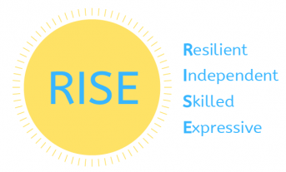
Curriculum Intent for Reading and Phonics
At The Avenue School, we aim to create a reading culture where enjoyment in reading a range of material is promoted by bringing text to life in meaningful and pleasurable ways. The acquisition of reading skills, including the teaching of phonics strategies, will support greater resilience, independence, skill and expression.
Reading | Resilient | Independent | Skilled | Expressive
Key Stage 1 | All pupils will have experienced a range of texts and will have developed preferences in the texts they wish to share with others or look at by themselves. All pupils will be familiar with a range of songs and rhymes and be able to show engagement with those that are particularly enjoyed. All pupils will be well paired with a key person that will support their ability to engage with and have a go at new tasks. All pupils will have had experienced of listening to a wide range of environmental sounds and have used a variety of resources to experiment with making their own sounds (including digital devices).  Most pupils will begin to develop a visual performance repertoire (i.e. be able to match identical pictures/objects/letters/numbers) . Most pupils will respond to symbols and photographs used to support daily routines. Most pupils will be able to identify themselves in a photograph.  Some pupils will be able to respond positively to an adult leading a story and will be able to predict and anticipate familiar phrases/ pictures, and choose texts independently. Some pupils will be able to answer simple questions when enjoying a book with an adult. Some pupils will have developed a generalised visual performance repertoire including non-identical matching, matching numbers and letters and sorting. Some pupils will be able to identify their name in print and will be able to use some phonemes.
Key Stage 2 | All pupils will have experienced a wider range of texts, and be able to demonstrate enjoyment in chosen texts and activities. All pupils will be able to respond to a familiar adult interacting with them.  Most pupils will be able to hold and turn the pages of a text. Most pupils will be able to anticipate during highly motivating songs, stories or rhymes and remain engaged in listening to those songs, stories or rhymes for short periods. Most pupils will be able to interact with texts as part of a group. Most pupils will be able to make requests for highly motivating items using their preferred mode of communication, when engaging in activities relating to a text. Most pupils will be able to follow instructions relating to daily routines. Most pupils will be able to identify some environmental sounds. Most pupils will have developed a generalised visual performance repertoire including non-identical matching, matching numbers and letters and sorting.  Some pupils will be able to recall familiar words and phrases in a range of texts including poems and non-fiction, and use phonic strategies to decode. Some pupils will be able to use their preferred mode of communication to comment about stories/ characters and sequence events as well as answer questions that confirm comprehension.
Key Stage 3 | All pupils will share a range of reading material with familiar adults. All pupils will respond to a growing range of familiar adults (i.e. classroom staff).  Most pupils will be able to respond to a range of symbols/ text in different environments in order to have greater independence in accessing the community. Most pupils will be able to engage with reading activities that are well matched to their level of reading or interests. Most pupils who use symbols to communicate will have a bank that they can use with increased levels of independence.  Some pupils will be able to read a range of genres for enjoyment using phonic strategies and sight recall. Some pupils will be able to communicate about plot/ style/ characters making inferences and predictions.

Curriculum Intent for Writing
We aim for our pupils to become functional and expressive writers. We provide a wide range of enjoyable and motivating experiences to maximize skill and promote resilience and independence.
Writing | Resilient | Independent | Skilled | Expressive
Key Stage 1 | All pupils will experiment with mark making using a range of mark making tools and sensory resources. All pupils will explore gross motor and fine motor movement in a range of motivating activities (including running, crawling, jumping, walking.) All pupils will experience opportunities to learn self-care tasks such as dressing, through curriculum sessions such as P.E. and Life Skills.  Most pupils will develope an early imitation repertoire or gross motor and fine motor movements.  Some pupils will give meaning to the marks they make. Some pupils will begin to use a tripod grip to produce/imitate pre-writing strokes. Some pupils will be able to sequence symbols with support to communicate about objects, people and events that are important, using either verbal or nonverbal communication. Some pupils will show hand dominance for some activities. Some pupils will show independence in some areas of self-care.
Key Stage 2 | All pupils will be able to demonstrate an early imitation repertoire (i.e. imitating with motivating objects or copying signs for motivating items). All pupils will be able to complete simple self-care tasks when prompted, such as some dressing tasks, tidying up, washing their hands. All pupils will be able to perform simple cause and effect actions relating to their preferred leisure activities (i.e. operating digital devices, turning on toys.)  Most pupils will have a generalised imitation repertoire of gross motor and fine motor movements and actions with objects.  Some pupils will be able to write on paper from left to right making attempts to form letters and words. Some pupils will be inspired to write or type words they see in the environment.
Key Stage 3 | All pupils will be able to use gross and fine motor skills to perform a wide range of self-care tasks.  Most pupils will be able to give meaning to their mark making.  Some pupils will be able to write or type for enjoyment or communication, spelling simple words correctly using phonic strategies or memory recall. Some pupils will be able to write or type for a variety of purposes demonstrating an awareness of audience.
Appendix 2 – Little Wandle Letters and Sounds Revised: Programme progression
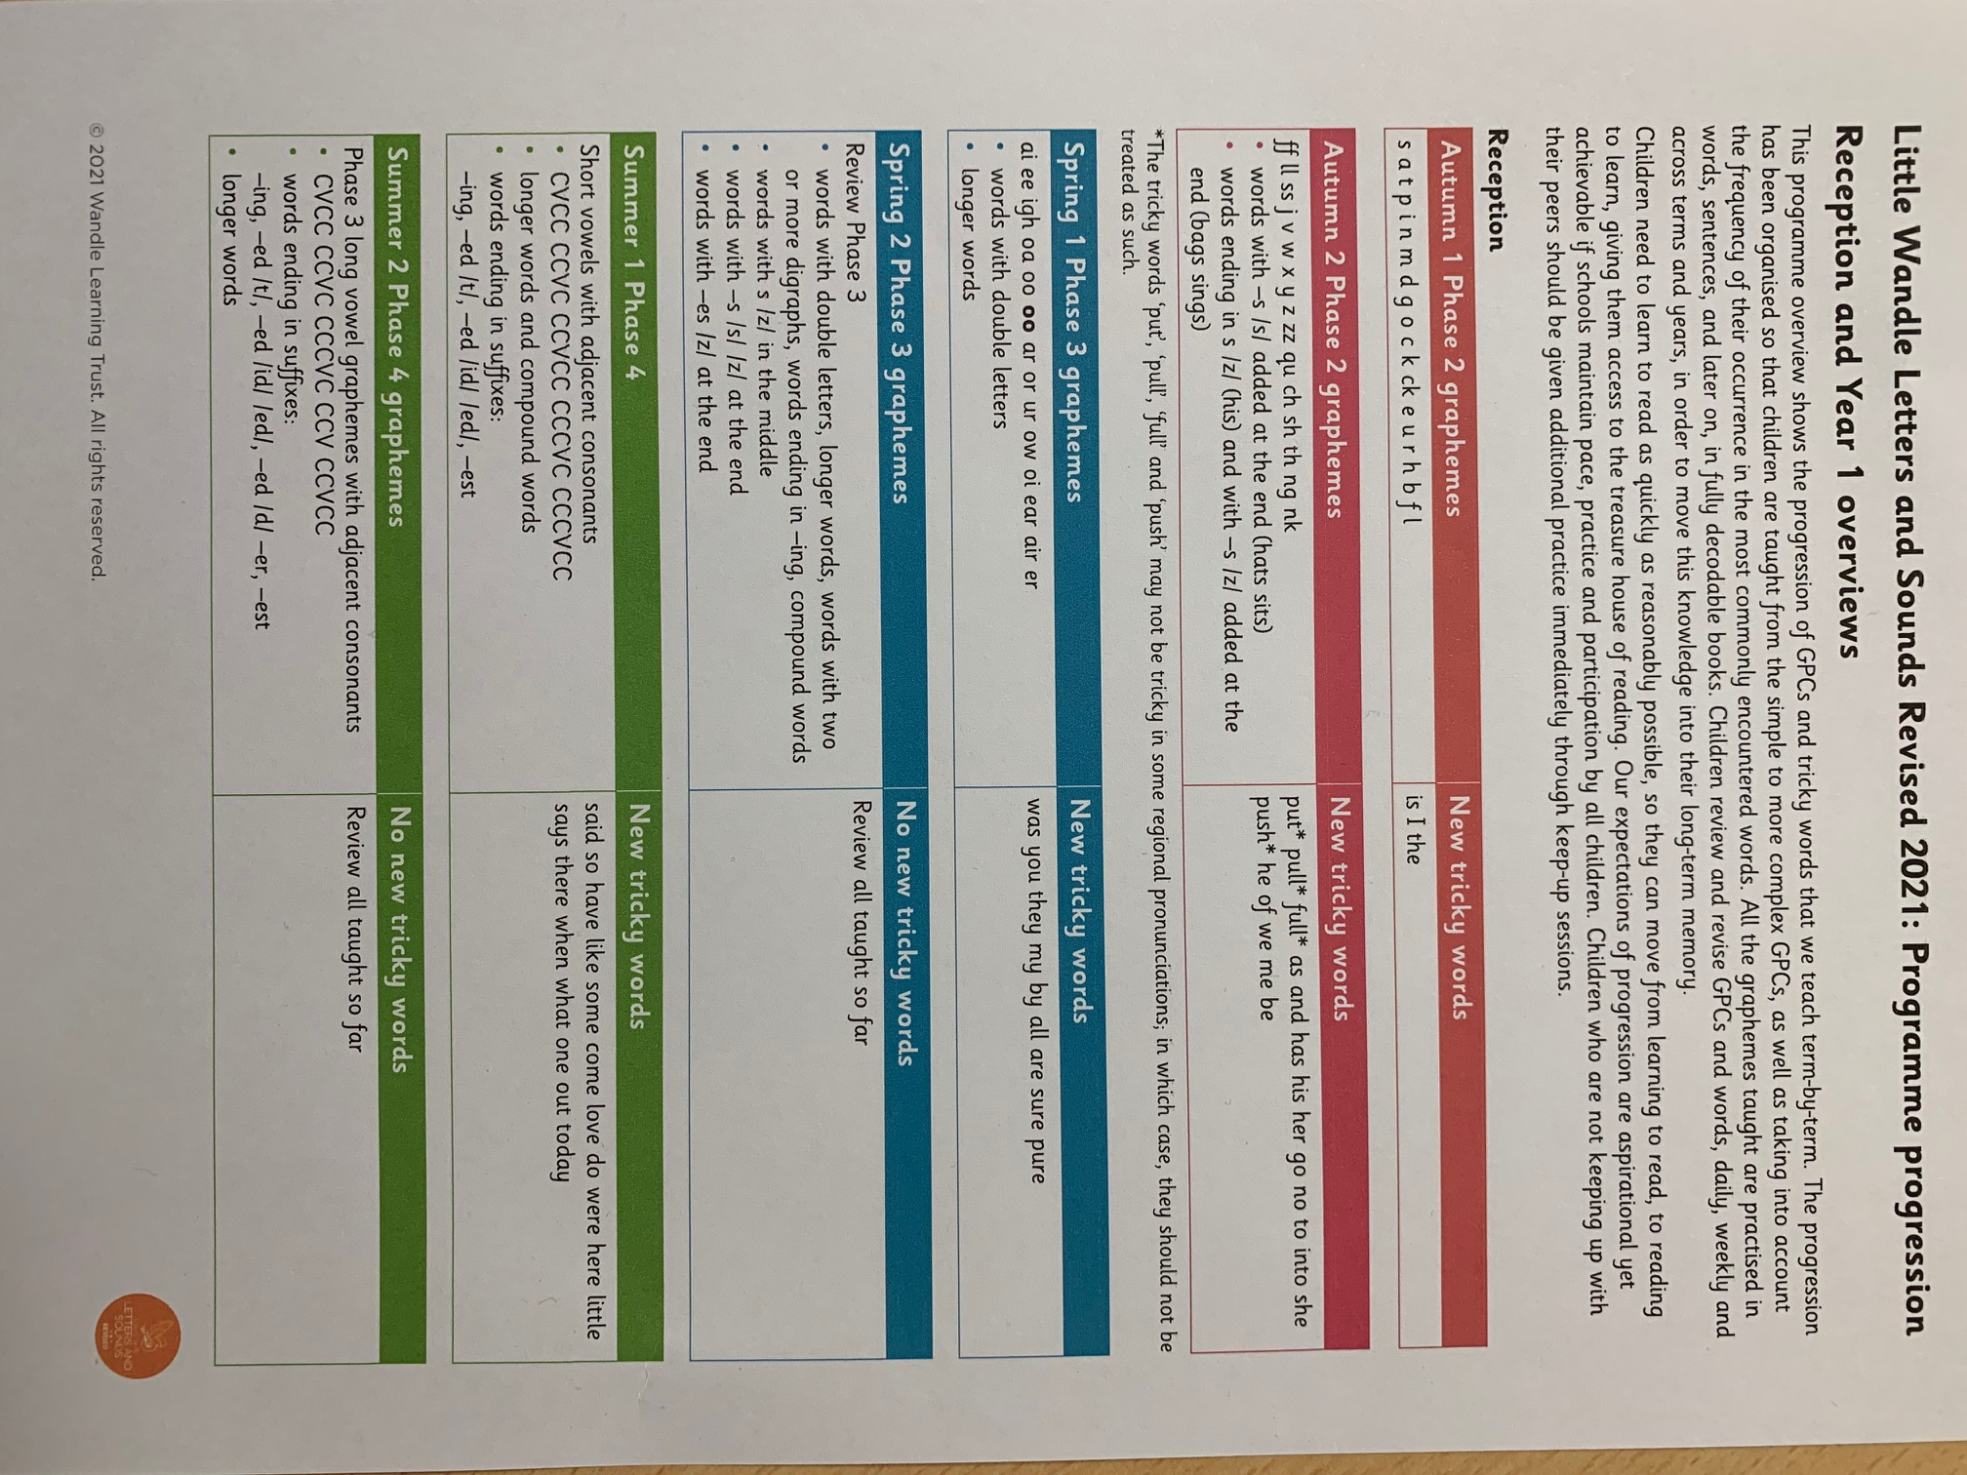

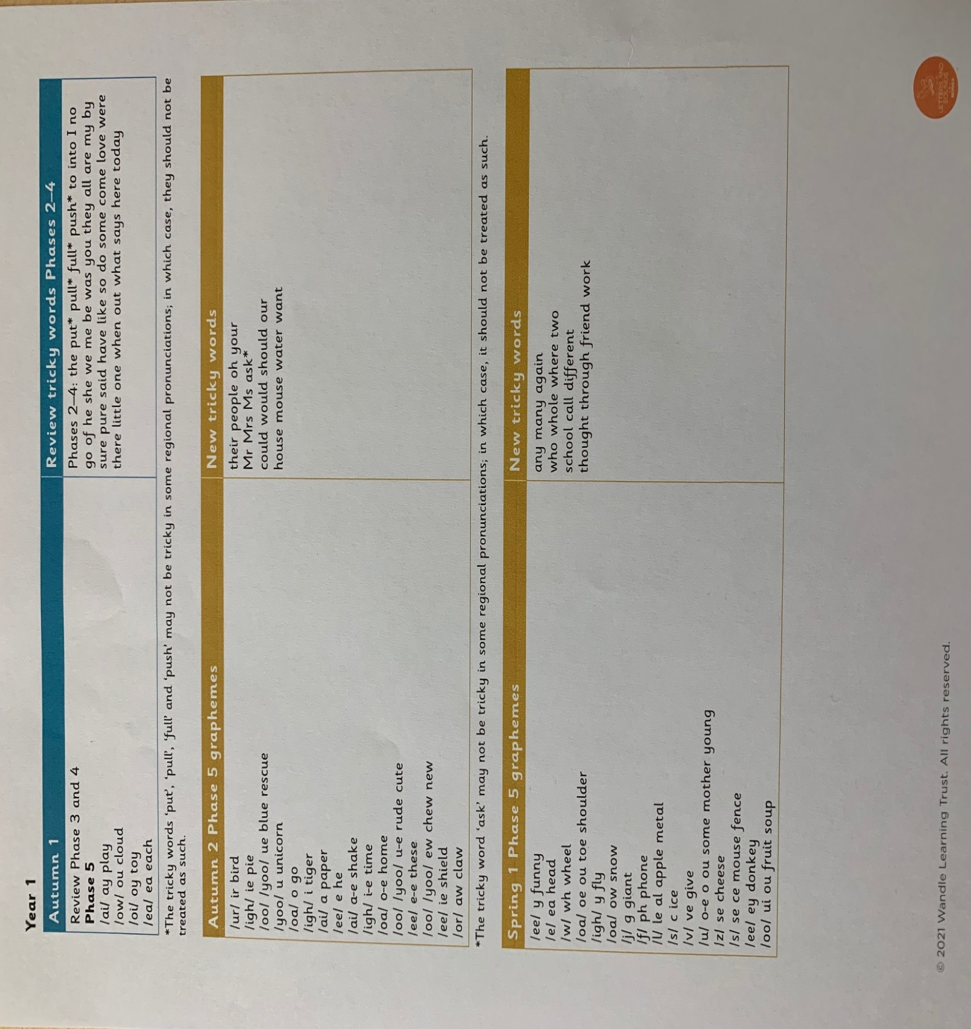

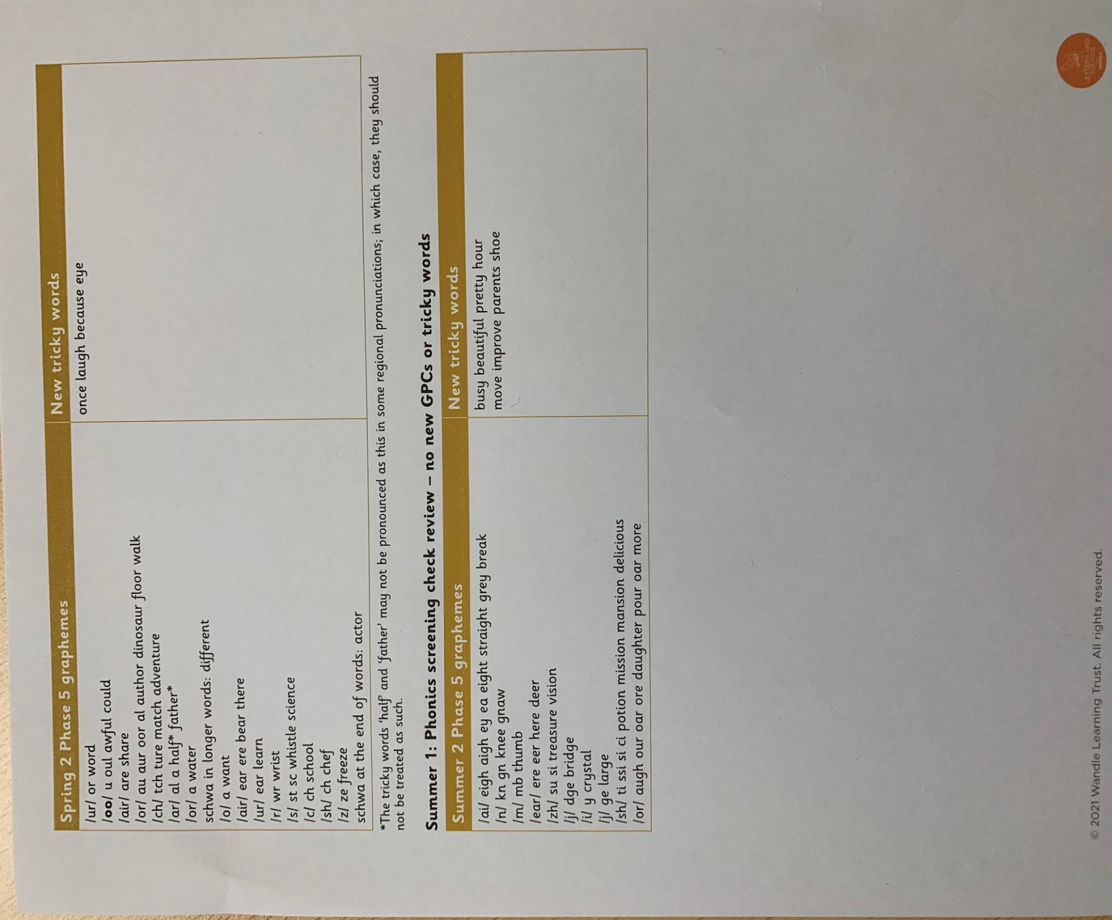

Appendix 3 – Supporting development of writing (activities to promote gross and fine motor skills and teach letter strokes/formation)

STAGE 1: Pre-writing Focus on:
- Adult facilitating the development of skills required for writing through play or other motivating activities
Method
- Joining the pupil in their play and gradually extending the activity to incorporate additional motor challenges in a playful way
- Using motivating activities to capture pupils’ attention and incorporating new concepts within these
Core stability: Ability to sit | Awarenesss and purposeful use of upper extremities: Hand dominance | Awareness of direction: Pre writing strokes
- Stimulating and strengthening activities for trunk:  - Jumping on mini trampoline  - Bouncing on a peanut ball (may be used as a seat)  - Play on stomach on peanut ball  - Co-op band activities (rowing/rocking front to back/ side to side, jumping)  - Obstacle courses | - Play on stomach where pupil is propped up on forearms and shoulders directly over elbows  - Crawling games (ie after adult crawling away payfully with motivating toy  - Grasping reaching/ pushing/ pulling within motivating play (facilitated by adult)  - Reaching for toys/ motivating objects held above head by an adult  - Holding on to hula hoop or resistant REP band as pulled around by adult (Can accompany with “Round the Garden song”)  - “Row your boat” in sitting on therapy ball (adult facilitating pushing/pulling with arms)  - Catching body weight on hands when rolled forward on stomach on peanut ball by an adult (hands flat on floor and shoulders directly above wrist)  - Activities on stomach on scooter board on resistant flooring (pulling/being pulled with hula hoop, propelling forward/ pushing back with arms)  - Co-op band activities, ie being pulled around as grasping, tug-of-war style games)  - Putty/pop tube play with adult manipulating material to adjust level of stimulation or motor challenge offered within the activity (depending on pupils ‘sensory and motor’ profiles  - Opportunities to explore mark-making with different tolls, in different media, materials  - In tactile and resistant materials  - foam, sand (dry/wet) soil, cornflour and water  - Using chunky crayons, thick chalk, marker pens  - On large pieces of paper on wall, floor  - On big pieces of cardboard, different textured paper (ie ridged border paper)  - Using sponges for painting | - Modelling directions within motivating play, that also provides an additional sensory component  - Ie ‘up’ ‘down’ with parachute when children underneath (visual and tactile)  - Lifting co-op or resistant REP band ‘up’ as pupil is grasping it, so they feel stretch of arms (proprioceptive feedback)  - Modelling BC Boom! Strokes/stroke sounds in Attention Autism  - Rocket balloons: prssh! (Stage 1)  - Pinwheel: (Stage 1)  - Raindrop: plop! (Stage 2)  - Car: vroom! (Stage 2)  - Introduction of ABC Boom! Sensory motor activities for different strokes (see appendix for activity ideas)  - Raindrop  - Pinwheel  - Rocket  - Cave  - Car  Important! Always attach sounds to stroke activities and make sure movement is in correct direction! Pinwheel and cave – counterclockwise,  Car – left to right

STAGE 2: Focus on:
- Continuing to promote motor skills required for writing
- Teaching strokes and letter formation
Method
- Incorporating additional sensory-motor component that offers strengthening or stimulating feedback within as many lessons and daily tasks as possible to make input more purposeful. Grading activities to provide ‘just right’ motor challenge (not too easy or too difficult)
- Using ABC Boom! Handwriting approach to introduce strokes and then letters/ numbers
Core stability: Ability to sit | Fine motor skills | Letter formation
- Incorporation of proprioceptive and vestibular rich activities for continued strengthening of trunk, incorporated within lessons  - Taking turns on trampoline or peanut ball for “good morning/afternoon”  - Use of peanut ball to sit on instead of chair  - Changing of positions of work, i.e. standing and writing on wall or easel, lying on stomach on floor  - Ensuring optimal position of table and chair heights for children when working at table  - Equipment provision (i.e. movin’sit cushion) as required | - Activities on stomach on peanut ball; catching weight and stabilising on both hands (flat on floor), then transferring to one hand while reaching with the other, i.e. to:  - Reach for shapes, symbols, letters to sort into categories  - Reaching to throw different coloured bean bags into boxes (can be incorporated within maths lesson, i.e. number, colour, size)  - To read different word cards held in front of ball by adult and identify the one that the teacher/adult asks for  - Use of resistant tools (i.e. tongs/tweezers, putty, clothes pegs) incorporated into lessons and daily activities, i.e.:  - Finding objects related to topic in putty (objects starting with ‘s’ for phonics, letter blocks)  - Making models of objects related to topic out of playdough/clay/putty  - Hanging sequence of story on line with clothes pegs  - Using tongs to hand out snack  - Continue to offer variety of writing tools - i.e. thick pencils, crayons, chalk, markers - for mark-making/writing. For children who present with poor fine motor skills or confidence in their skills, the demands of using a pencil may impact on their motivation for and confidence within writing  - Colouring:  - Use of PVA glue to form shapes to be coloured within (after glue has dried!) to give additional tactile feedback of borders. (Children who are able to, can make shapes with glue themselves – providing additional challenge)  - Colouring on cardboard (or on paper over cardboard)  Tip: Use of smaller pictures (A5 vs A4) to keep child's interest and promote child's success and sense of accomplishment within colouring task | - Teaching strokes using ABC Boom approach. The introduction of each stroke should always include the showing of the A3 picture, adults modelling the sound as demonstrating the direction of the stroke and the children experiencing the direction of the stroke with their whole body (see associated whole body activity for each stroke)  - Practicing strokes with large arm movements and against resistance  - Introduction of letters once all the strokes required for letter are known  - Practicing strokes/letters in as many different and fun ways as you can. i.e using: Glitter pens, glue and glitter, ribbons, torch on wall, water gun (on floor or wall outside!)  - Once children show understanding of stroke and can produce with large arm movements, they may be given opportunity to use pencil and paper if they choose. If they are not ready or resistant, continue to practice strokes/ letters with large movements and against resistance. Moving to paper and pen task too early can not only impact on a child‘s confidence and motivation to write, but their efficiency within writing (i.e. due to poor motor skills or decreased consolidated knowledge of letter strokes/formation).

STAGE 3: Focus on:
- Increasing efficiency and presentation of written work (including correction of errors)
- Introducing joined up writing
Method
- Involving pupil in self-assessing their work to create goals for their own writing
- Using ABC Boom! Strategies to target letter reversals, poor letter formation
- Using visual strategies for writing on a line, size of letters, spacing
Core stability: Ability to sit | Fine motor skills | Written work
- Continuing to ensure optimal positioning, adapting furniture as required  - Equipment provision (movin’sit, footstool) as required) | - Continuation of activities for hand strength and stability (see above)  - Use of adaptive equipment to increase efficiency or endurance within writing (inclined planes, pencil grips) | - Use of ABC Boom! To target specific poor letter formation  - Use of specific ‘sky/tree/root’ worksheets to teach or review where each letter starts/sits/ends (ie long @raindrops stroke such as h,t,l start in the sky/blue area, strokes such as g,p,q dip under the ground into the roots/ brown area, other letters stay in the green/tree area)  - Use highlighters as visual cue to shape letter size, ie if pupil writes large letters, start with thick highlighter (horizontal) line that they have to keep their letters within and then slowly decrease the width of the highlighter to promote smaller letter size  - Use stickers for spaces  - Joined-up writing should only be introduced once pupils are able to produce all letters securely with the correct formation  - When teaching joined-up writing, upper-case letters are separate and only the lower-case letters are joined up

Appendix 4 – Building Blocks of Development

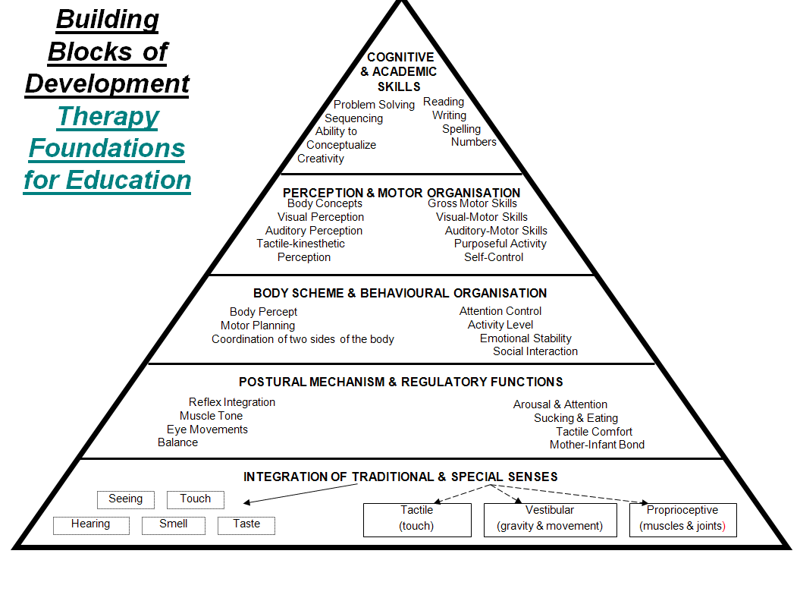

Appendix 5 – Teaching strokes and letters (ABC Boom!)
Strokes | Letters
- Show the picture of the stroke  - Trace over the stroke with your finger while making the corresponding sound  - Model making the stroke on large vertical surface (i.e whiteboard, chalkboard)  - If appropriate, point out examples of letters that contain the stroke (i.e letters in pupil’s names)  - Do the whole body activity that is associated with the stroke, while producing the corresponding sound  - Have pupil trace strokes using large movements and muscular resistance  - On whiteboard (tracing over stroke with finger/eraser)  - In large trays of tactile or resistant materials  - With brush/ sponge/ paint  - Chalkboard (tracing over stroke with another colour chalk, wet/dry sponge  - When they are able to trace, have pupil draw stroke in the air  - After a demonstration prompt from an adult (ie imitation)  - On their own (without a mode)  - On their own with their eyes closed  - When the motor pattern is integrated, practise on paper  - Tracing over enlarged picture with finger  - Tracing over enlarged picture with marker  - Additional worksheets can be offered if pupil shows interest/ chooses | - Show or write the letter on a large screen in front of the pupil and name it  - Trace over the letter with your finger while making the corresponding sounds and add the corresponding drawings (for the strokes)  - Search for letters within words (i.e. pupil’s name cards)  - Have pupil trace letter using large movements and muscular resistance  - On white board (tracing over stroke with finger/eraser/sponge)  - In large trays of tactile or resistant materials  - Chalkboard (tracing over stroke with another colour chalk, wet/dry sponge)  - When they are able to trace letter, have pupil “write” the letter in the air  - After a demonstration prompt from adult (i.e. imitation)  - On their own (without a model)  - On their own with their eyes closed with associated sounds  - On their own with their eyes closed and without making associated sounds  - In different ways (quickly, slowly, big, small) with their eyes closed  - When the motor pattern for the letter is integrated, practise on paper  - Tracing letter using finger  - Tracing letter using pencil  - Copying letters in the spaces provided in their workbooks  - Ask pupils to find their “champion” letter  - Ask pupils to write words with the new letters they have learned
Additional guidance to teaching strokes/letters
- Start with raindrop (easiest), ideally addressing diagonal lines last (as these are the most difficult)
- Avoid teaching strokes with opposite directions (i.e. raindrop/rocket, cave/robot) directly after each other
- Sequence of strokes introduced can be adapted based on what letters you want to introduce first
- Always remember to model the stroke in the correct direction (car/grasshopper: always left to right, cave/pinwheel: anti-clockwise as pupils see it)
Letter groups
Letters starting with raindrop: b, h, i, k, l, m, n, p, r, t, B, D, E, F, H, I, K, L, M, N, P, R, T
Letters starting with cave: a, c, d, g, q, s, C, G, S
Letters starting with pinwheel: f, o, O, Q
Letters starting with car: e, z, Z
Letters starting with slide: v, w, x, y, A, V, W, X, Y
Others: j, J (earthworm), u, U (dolphin)
Letter formation with ABC Boom! strokes
a | (snoring sound), prrsshh, plop! | A | Weee, weee!, vroom!
b | Plop, prrsshh, crank | B | Plop, crank, crank
c | (Snoring sound) | C | (snoring sound)
d | (snoring sound), prrsshh, plop! | D | Plop, crank
e | Vroom, (snoring sound) | E | Plop, vroom, vroom, vroom
f | (blowing sound), plop, vroom! | F | Plop, vroom, vroom
g | (snoring sound), prrsshh, yoop! | G | (snoring sound), vroom
h | Plop! boing! | H | Plop, plop, vroom
i | Plop! Tick | I | Plop, vroom, vroom
j | Yoop, tick | J | Yoop, vroom
k | Plop, weee! Weee! | K | Plop, weee, weee
l | Plop! | L | Plop, vroom
m | Plop, Boing, Boing! | M | Plop, weee, uuhhp, plop!
n | Plop, boing | N | Plop, weee, prrssh!
o | (blowing sound) | O | (Blowing sound)
p | Plop, prrsshh, crank | P | Plop, crank
q | (snoring sound), prrsshh, plop! | Q | (blowing sound), weee!
r | Plop, boing! | R | Plop, crank, weee!
s | (snoring sound), crank! | S | (snoring sound), crank!
t | Plop, vroom! | T | Plop, vroom
u | Splash, plop! | U | Splash!
v | Weee, uuhhp! | V | Weee! Uuhhp!
w | Weee! Uuhhp, weee, uuhhp! | W | Weee! Uuhhp! Weee! Uuhhp!
x | Weee! Weee! | X | Weee! Weee!
y | Splash, yoop! | Y | Weee! Uuhhp! Plop!
z | Vroom, weee, vroom | Z | Vroom! Weee! Vroom!
Appendix 6 - Little Wandle Letters and Sounds Revised grapheme information sheets

Phase 2 grapheme information sheet 1
Grapheme and mnemonic | Picture card | Pronunciation phrase
s | snake | Show your teeth and and let the s hiss out ssssss ssssss
a | astronaut | Open your mouth wide and make the a sound at the back of your mouth a a a
t | tiger | Open your lips; put the tip of your tongue behind your teeth and press t t t
p | penguin | Bring your lips together, push them open and say p p p
i | iguana | Pull your lips back and make the i sound at the back of your mouth i i i
n | net | Open your lips a bit, put your tongue behind your teeth and make the nnn sound nnn
m | mouse | Put your lips together and make the mmmmm sound mmmmm
d | duck | Put your tongue to the top and front of your mouth and make a quick d sound d d d
g | goat | Give me a big smile that shows your teeth; press the middle of your tongue to the top and back of your mouth; push your tongue down and forward to make the g sound g g g
o | octopus | Make your mouth into round shape and say o o o
c | cat | Open your mouth into a little smile; make your tongue flat and move it up towards the top of your mouth to say c c c
k | kite | Open your mouth into a little smile; make your tongue flat and move it up towards the top of your mouth to say kkk
ck | sock | Open your mouth into a little smile, make your tongue flat and move it up towards the top of your mouth to say c c c c
e | elephant | Open your mouth wide and say e e e
u | umbrella | Open your mouth wide and say u u u
r | rainbow | Show me your teeth to make a rrrrr sound rrrrr rrrrr
h | helicpopter | Open your mouth and breathe out sharply h h h
b | bear | Put your lips together and say b as you open them b b b
f | flamingo | Open your lips a little; put your teeth on your bottom lip and push the air out to make the sound fffff fffff
l | lollipop | Open your mouth a little; put your tongue up to the top of your mouth, behind your teeth, and press lllll lllll

Phase 2 grapheme information sheet 2
Grapheme and mnemonic | Picture card | Pronunciation phrase
j | jellyfish | Pucker your lips and show your teeth use your tongue as you say j j j
v | volcano | Put your teeth against your bottom lip and make a buzzing vvvvv vvvvv
w | wave | Pucker your lips and keep them small as you say w w w
x | box | Mouth open, then push the cs/x sound through as you close your mouth cs cs cs (x x x)
y | yoyo | Smile, tongue to the top of your mouth, say y without opening your mouth yyy
z | zebra | Show me your teeth and buzz the z sound zzzzz zzzzz
qu | queen | Pucker your mouth, then open it as you say qu qu qu
ch | cherry | Pucker your lips and show your teeth; use your tongue as you say ch ch ch ch
sh | shells | Show me your teeth and push the air out shshshshsh shshshshsh
th | thumb | Voiced: Tongue on your teeth, teeth almost closed to make a ‘buzzing’ th th th Unvoiced: Tongue on your teeth; push the air out th th th th
ng | ring | Open your mouth a bit and then use your tongue at the back of your mouth to say ng ng ng ng
nk | Pink panda | Open your mouth a bit and then use your tongue at the back of your mouth to say ngk ngk ngk

© 2021 Wandle Learning Trust. All rights reserved

